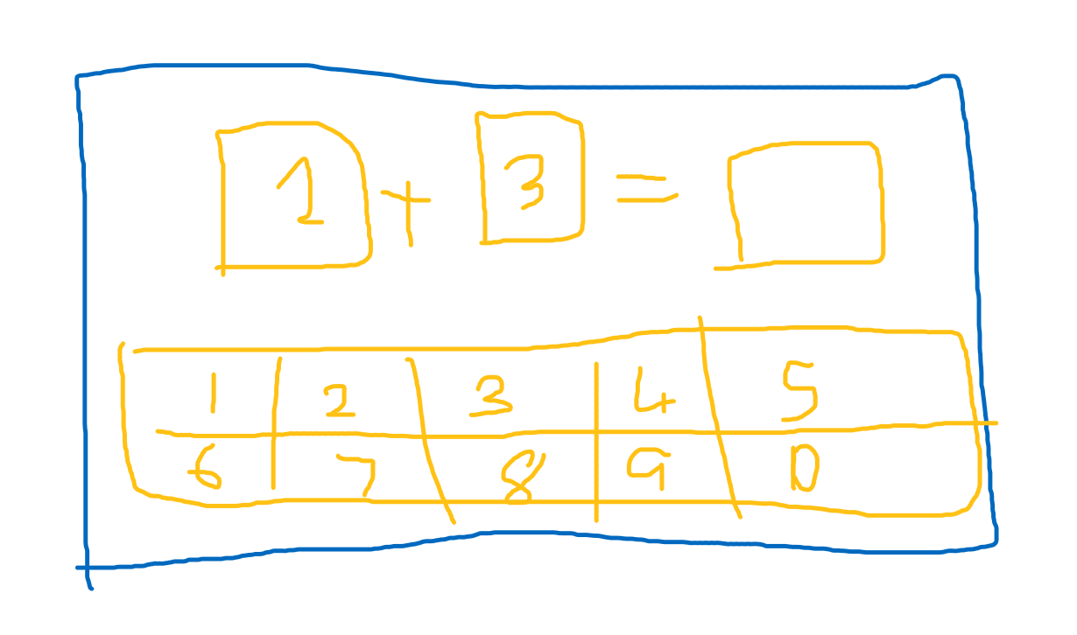  
Math layout  
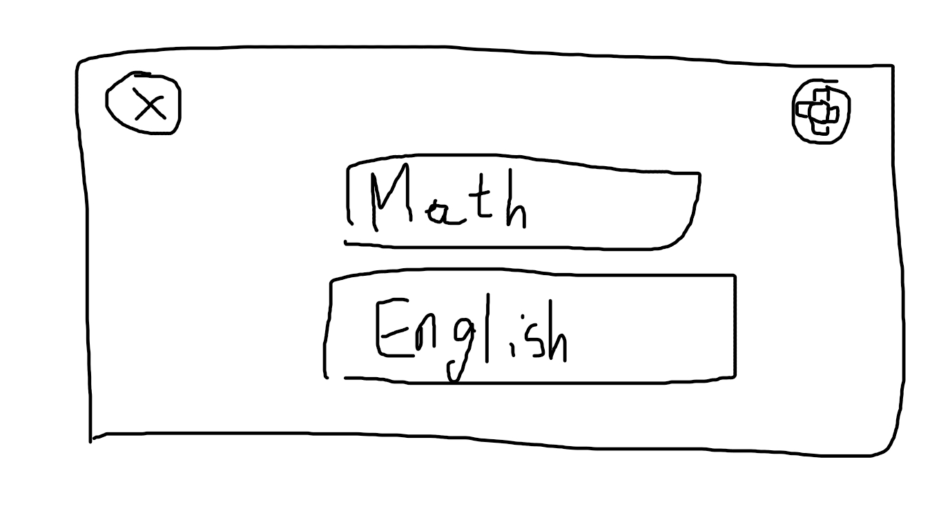

Main Menu layout  
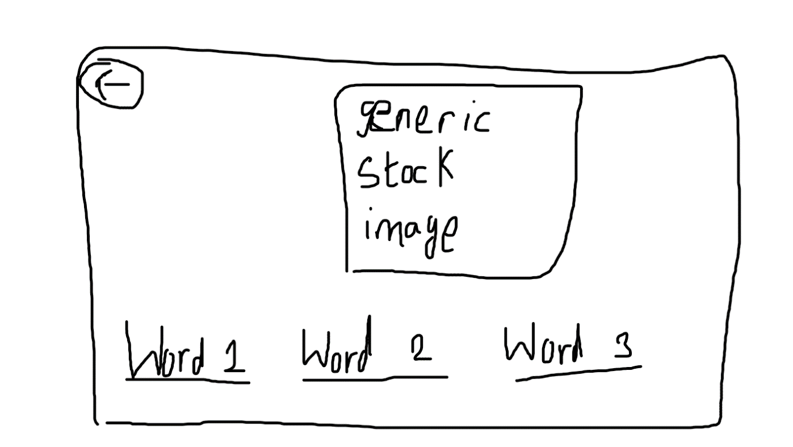  
English layout  
  
Idea draft:

Word Association and Simple math game for kids

Aimed for 3-7 year old children

Word Association game to improve english skills in a fun and engaging way

Math game to train their math skills, which helps a lot in the future

features:

Vibrant graphics and animations to engage them for a long time

Simple questions that are easy to solve